**Back-End Changes**

You can make the following changes in the job Add page:

1. Update the following industries in the add company page

In the Industry Filter

**List of Industries:**

* Automotive
* Engineering
* Construction
* Real Estate
* Accounting & Tax
* Banking & Finance
* Manufacturing
* Light Industrial
* Legal
* Healthcare
* Pharmaceutical
* Telecommunications
* Power & Energy
* Transportation
* Warehousing
* Food & Beverages
* Information Technology
* Human Resources
* Sales & Marketing
* Logistics & Supply Chain
* Aerospace & Defense
* Hospitality & Tourism
* Retail
* Oil & Gas
* Biotechnology
* Agriculture
* Environmental Services
* Media & Entertainment
* Education
* Non-Profit
* Medical Devices
* Government & Public Sector
* Security & Law Enforcement
* Consumer Goods
* Chemical & Petrochemical
* Insurance
* Mining

1. We need to remove the industry tab from this page because we are adding it in the Add Company Page. Once we add the industry for a company, it will automatically show in the Add Job page. Then we can choose the Job by Function. Rename the Job by Function to **Departments/Functions** we need to update the fields as per below:

1. **Update the Final List of Departments/Functions:**

* Administration
* Business Development
* Corporate Social Responsibility
* C-Level Executive
* Operations
* Quality Control/Assurance
* Health, Safety, and Environment
* Maintenance
* Production/Manufacturing
* Engineering
* Supply Chain/Logistics
* Research and Development
* Purchasing/Procurement
* Human Resources
* Finance and Accounting
* Sales
* Marketing
* IT/Information Technology
* Customer Service
* Warehouse/Inventory
* Project Management
* Legal and Compliance
* Estimating
* Design and Architecture
* Surveying
* Audit and Assurance
* Taxation
* Advisory/Consulting
* Bookkeeping and Payroll
* Risk and Compliance
* Training and Development
* Facilities Management
* Transportation
* Legal and Intellectual Property
* Communications/Public Relations
* Product Management
* Customer Success/Client Relations
* Event Management
* E-Commerce
* Data Science/Analytics
* Sustainability/Environmental Management
* Security (Physical and Cyber)
* Procurement & Contract Management
* Creative/Design (Digital/Graphic)
* Media and Content Production
* Corporate Strategy
* Diversity, Equity, and Inclusion (DEI)

We need to update the submission form by adding the following fields:

1. **Current Location**
2. **Willing to Relocate** (Drop-down options: Yes/No/Not Applicable)
3. **Availability for Interview** (Text field for candidate to enter their availability)
4. **Years of Relevant Experience** (Text field for the candidate to specify their relevant experience)
   * **Additional Information**: How many Years of Relevant Experience does the Candidate have? (Mention the company/projects where they gained the similar experience?)

1. Need to remove the highlighted column or show it in the Candidate Display Page. Replace it with the job Location. We need to show the Submission Date as well.

1. We need to add a field to add notes every time we change the Status of the submissions. The Recruiter must know the reason for rejection or each stage.
2. Most Importantly, for every action both the recruiter and the admin must receive email messages.
3. Every time there is a new job added, or job status updated, or candidate submitted to client or shortlisted for interview, we need to send email communications to relevant users.
4. Need to show the number of jobs in the front end as well as in the back end.
5. Need to give an option to push the job to the top for an important position which was added earlier.
6. After adding a job if I click on View, it gives the error. Refer screenshot.

1. All locations are not displaying for the job. For the following jobs I added 3 different locations. However, it is showing only 1 location. We need this to be displayed in both front-end and back-end.

1. We need to create an option for the admin to send communications messages or updates about the jobs or all emails to all users when needed. It can be about any existing job or new job requirements or about any announcements.
2. Change the font color to white in the header. . Display all headers. Remove the last 3 fields and replace them with Job ID, Salary, Industry, Submissions, Status

* The Search filters in the job listing page in the back end need to be organized by Date, Industry, Job Status, Client, Location

1. The Job Status needs to be updated as follows: Active, On Hold, Closed. Remove the other fields.

1. We need to add one more field to the job display page: Job Status.

1. There should be filter for both the Recruiters and Admins to filter jobs by different values, such as industry, location, job title. Etc.
2. We need to add more fields in the Add New Company Page: Company Website, Company Industry, Company City, Company State, Company LinkedIn Page, Company Phone Number, Fee %, Warranty, Refund Policy (Yes/No Drop Down)

Add another sub-field called Company Contact Details:

Primary Contact Person Name, Contact Phone, Email address, Designation,

all these forms can be non-mandatory.

Same fields to be shown in the below screenshot.

1. Need to provide a search option for companies: search by name, search by industry, location, State,

1. Need to remove the 2nd Job Application field. Rename This Tab to “Submissions”

1. In the candidate Display page change the Font to White Color. Rename as Submissions Home Page and Link to Submission List.

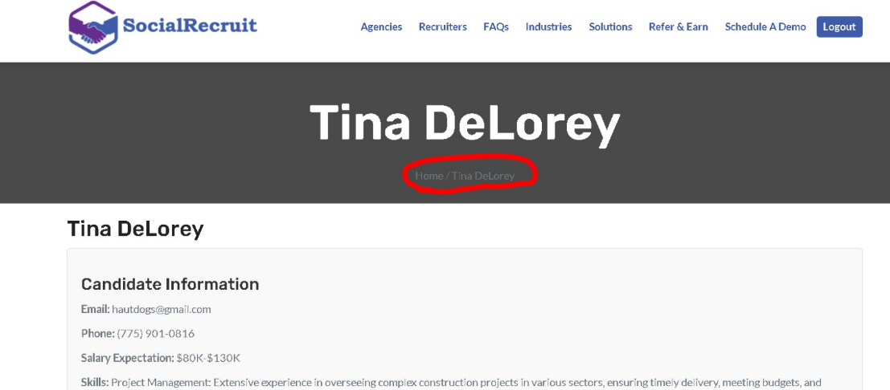

1. In the job add page, move the salary unit to the right side of the salary field. You can reduce the size of the salary field if you want to. Remove the stroked fields.

1. Create 2 fields where the Dollar sign is by default it picks up. In the fields we can simply enter the range.

$40,000 - $60,000

$60,000 - $80,000

The same rule applies for commission field.

1. After adding a new job, it should take us to the Job Listing page.
2. While deleting a job it should give us a pop-up message saying, “Do you really want to delete this job?”
3. Generate a Unique Referral Code for each User which can be shared with other registrants. They can enter the referral code to get the referral bonus.

In the front-end on both Sign Up pages we need to add another field to enter the Referral Code if they are referred by another recruiter.

Field Name: Do You have a Referral Code?

1. We need to stop duplicate submissions. As you can see in the screenshot below, the same candidate was submitted twice by the recruiter. We also discussed some candidates being submitted by different recruiters. We need to give them a message saying the same candidate was submitted for this job by another recruiter.

There should be an option to delete the candidate if it was by mistake. Remove the Tester Profile.

1. All Users when they sign up, they should get the following email immediately:

Subject: Welcome to [Your Company Name] – Let’s Get Started!

**Subject:** Welcome to **SocialRecruit** – Let’s Get Started!

**Dear [User’s Name],**

Welcome to **SocialRecruit**! We're excited to have you on board.

Thank you for joining a community dedicated to empowering independent recruiters and recruitment agencies. We’re here to help you make the most of your experience with us.

**What’s Next?**

* **Explore Our FAQs**: Learn more about how **SocialRecruit** can support your recruitment efforts.
* **Browse Job Opportunities**: Discover a wide range of job listings across various industries.
* **Submit Candidates**: Match your candidates with open positions listed on our platform.
* **Stay in Touch**: Communicate with our team for timely feedback on your submissions.
* **Earn Commissions**: Earn up to **$15,000** for each successful hire through your referrals!

To learn more or get personalized assistance, feel free to [schedule a demo] or [book a call] with our team.

If you have any questions or need support, don’t hesitate to reach out—we’re here to help!

Thank you for joining **SocialRecruit**, and we look forward to working with you.

**Warm regards,**  
The **SocialRecruit** Team

Can we try to remove the lines shown on the jobs listing page?

Can we freeze the header of the job listing?

