Ingen De Jager Hiring Manager OnlyHire.Me

Murfreesboro, TN 37127

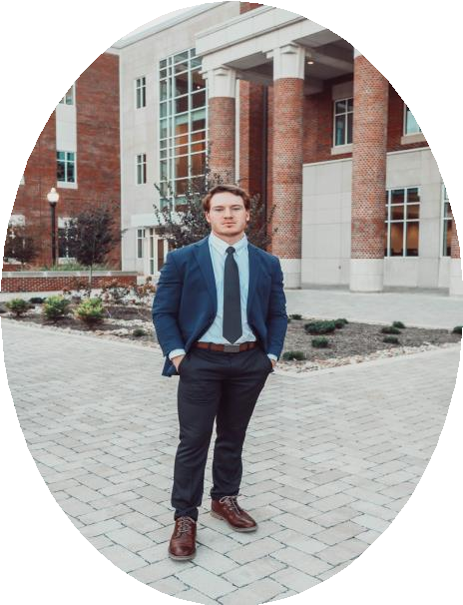

HAMILTON PARSONS

Project Engineer

**CONTACT**

PHONE:

931-607-1896

Address:

1305 Glenoaks Road

Shelbyville, TN 37160

EMAIL:

[hamiltonparsons@gmail.com](mailto:hamiltonparsons@gmail.com)

Dear Ingen,

I am writing to express my interest in the development and infrastructure design position listed on Indeed. With two years of civil construction experience, I am confident that I possess the skills necessary to be an asset to your team.

While at TN Technological University, I was a member of a senior design project with AECOM. While working on this project, I became familiar with the permitting process as well as other regulations associated with construction. I was specifically responsible for the roadway design for this project but collaborated with other group members on their scopes of work.

Working in the field for Rogers Group and Wayne Brothers has given me a deeper understanding of civil construction and design. At these companies, I was able to see the actual construction process as well as the issues that the crews faced. This experience will allow me to think ahead to improve constructability and spot issues before the design is finalized. This experience will also help to bridge the gap between the office and the field.

An opportunity such as this will allow me to pursue my P.E. license and be mentored by professionals with years of experience. I believe that these past experiences have given me many of the tools necessary to be a successful development and infrastructure design engineer. With my eagerness to learn and determination, I can develop the remaining skills.

Thank you for your time and consideration. I welcome the opportunity to discuss how my background aligns with your team’s goals.

Sincerely, Hamilton Parsons

|  |
| --- |
| **milton Parsons**  1305 Glenoaks Road, Shelbyville, TN 37160  931-607-189 [hamiltonparsons@gmail.com](mailto:hamiltonparsons@gmail.com) **Linked In**  **Objective**  I plan to obtain a position within civil engineering that will give me the opportunity to develop my skills and pursue my professional engineer license. |
| **Civil Related Work Experience**  **Rogers Group Summer 2022**   * Roadway construction crew * Gained hands-on experience * Improved communication skills * Observed construction processes * Worked 60 hours per week   **Lithko Contracting Summer 2023**  Worked on site at a hospital expansion   * Completed and submitted multiple RFIs * Assisted in surveying and site layout * Performed pre-pour QC inspections on rebar * Estimated quantities by interpreting site drawings * Gained hands on experience through working alongside crewmembers   **Wayne Brothers Jan 4, 2024 – Present**  Project Engineer   * Managed site logistics * Managed material procurement * QC pre-pour inspections * Organized submittals and RFIs * Gained field experience * Managed crews of form carpenters and concrete finishers |
| **Education**  **Tennessee Technological University December 2023**   * Bachelor of Science/Civil Engineering * 3.2 GPA * Foundational knowledge of SolidWorks and AutoCAD * Obtained E.I.T Certification |
| **Campus Organizations**  **ASCE Member**   * Networked with other students * Attend meetings to gain insight |

**Ha**



* Gained better understanding of the challenges that Civil Engineers face
* Represented ASCE on the Engineering Joint Council

**Other Notable Skills**

* Some experience with permitting and civil site through senior design project with AECOM
* Technical writing
* Public Speaking

2