DIANE L. KLEIN

65 MacArthur Lane, Unit 7

Stamford, CT 06902

Telephone: (203) 952-3385 [dlkleinesq@gmail.com](mailto:dlkleinesq@gmail.com)

April 24, 2025 Dear Sir/Madame:

I am writing with regard to the Real Estate Attorney – Litigation Practice Group position. The role is one for which I am uniquely qualified.

As you can see from my resume, I have quality legal experience in Civil Litigation including the areas of Real Estate, Commercial Litigation, Collections, and Small Estate Administration. My skills include drafting and arguing appeals before the First and Second Departments in New York as well as the Fourth District Court of Appeal in Florida; State and Federal Court appearances for conferences, Small Claims trials, hearings, motions, and oral arguments; second chairing trials and leading arbitrations; conducting and defending EBTs; and drafting documents for all phases of litigation from Complaints to Jury Verdict and Charges.

My current position has introduced me to various aspects of Real Estate Law including deceased tenant (Estate Administration) matters, as well as plenary commercial and residential collections matters.

I have been working 100% remotely since October 2023, but would be willing to consider a 2- day/week temporary hybrid schedule until you are comfortable with my working remotely.

I look forward to speaking with you soon about setting up a phone or Teams interviewco. Thank you in advance.

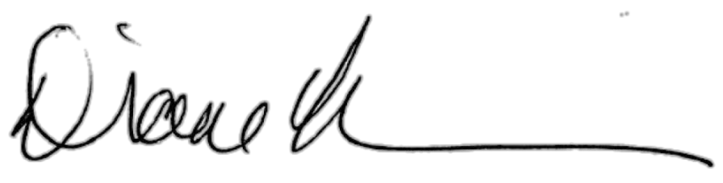Sincerely,

Diane L. Klein